Java programming 2_1

import java.awt.*;

import java.awt.event.*;

import javax.swing.*;

import javax.swing.border.*;

public class JavaBank extends JFrame {

/**

*

*/

private static final long ***serialVersionUID*** = 1L;

// Make these variables publicly available

public String Name;

public int Accountnum;

public int Balance;

// JPanel for user inputs

private JPanel inputDetailJPanel;

// JLabel and JTextField for account name

private JLabel NameJLabel;

private JTextField NameJTextField;

// JLabel and JTextField for account number

private JLabel AccountnumJLabel;

private JTextField AccountnumJTextField;

// JLabel and JTextField for balance

private JLabel BalanceJLabel;

private JTextField BalanceJTextField;

// JLabel and JTextField for withdraw

private JLabel DepositJLabel;

private JTextField DepositJTextField;

// JLabel and JTextField for Withdraw

private JLabel WithdrawJLabel;

private JTextField WithdrawJTextField;

// JButton to create account

private JButton CreateAccountJButton;

// JButton to delete account

private JButton DeleteAccountJButton;

// JButton to make transaction

private JButton TransactionJButton;

// JButton to display account

private JButton DisplayJButton;

// JLabel and JTextArea to display account details

private JLabel displayJLabel;

private static JTextArea *displayJTextArea*;

// constants

//public final static Maximum Accounts that can be created;

public final static int ***MaxAccounts*** = 10;

// one-dimensional array to store Account names as Empty or Used

static String *AccountNames*[] = new String[***MaxAccounts***];

// two-dimensional array to store Account details

static Account *myAccounts*[] = new Account[***MaxAccounts***];

static int *noAccounts* = 0;

// constructor

public JavaBank() {

for (int i=0; i <10; i++) {

*AccountNames*[i] = "EMPTY";

//System.out.println(AccountNames[i]);

}

createUserInterface();

}

// create and position GUI components; register event handlers

private void createUserInterface() {

// get content pane for attaching GUI components

Container contentPane = getContentPane();

// enable explicit positioning of GUI components

contentPane.setLayout(null);

// set up inputDetailJPanel

inputDetailJPanel = new JPanel();

inputDetailJPanel.setBounds(16, 16, 208, 250);

inputDetailJPanel.setBorder(new TitledBorder("Input Details"));

inputDetailJPanel.setLayout(null);

contentPane.add(inputDetailJPanel);

// set up NameJLabel

NameJLabel = new JLabel();

NameJLabel.setBounds(8, 32, 90, 23);

NameJLabel.setText("Name:");

inputDetailJPanel.add(NameJLabel);

// set up NameJTextField

NameJTextField = new JTextField();

NameJTextField.setBounds(112, 32, 80, 21);

NameJTextField.setHorizontalAlignment(JTextField.***RIGHT***);

inputDetailJPanel.add(NameJTextField);

// set up AccountnumJLabel

AccountnumJLabel = new JLabel();

AccountnumJLabel.setBounds(8, 56, 100, 23);

AccountnumJLabel.setText("Account Number:");

inputDetailJPanel.add(AccountnumJLabel);

// set up AccountnumTextField

AccountnumJTextField = new JTextField();

AccountnumJTextField.setBounds(112, 56, 80, 21);

AccountnumJTextField.setHorizontalAlignment(JTextField.***RIGHT***);

inputDetailJPanel.add(AccountnumJTextField);

// set up BalanceJLabel

BalanceJLabel = new JLabel();

BalanceJLabel.setBounds(8, 80, 60, 23);

BalanceJLabel.setText("Balance:");

inputDetailJPanel.add(BalanceJLabel);

// set up BalanceTextField

BalanceJTextField = new JTextField();

BalanceJTextField.setBounds(112, 80, 80, 21);

BalanceJTextField.setHorizontalAlignment(JTextField.***RIGHT***);

inputDetailJPanel.add(BalanceJTextField);

// set up DepositJLabel

DepositJLabel = new JLabel();

DepositJLabel.setBounds(8, 104, 80, 23);

DepositJLabel.setText("Deposit:");

inputDetailJPanel.add(DepositJLabel);

// set up DepositJTextField

DepositJTextField = new JTextField();

DepositJTextField.setBounds(112, 104, 80, 21);

DepositJTextField.setHorizontalAlignment(JTextField.***RIGHT***);

inputDetailJPanel.add(DepositJTextField);

// set up WithdrawJLabel

WithdrawJLabel = new JLabel();

WithdrawJLabel.setBounds(8, 128, 60, 23);

WithdrawJLabel.setText("Withdraw:");

inputDetailJPanel.add(WithdrawJLabel);

// set up WithdrawJTextField

WithdrawJTextField = new JTextField();

WithdrawJTextField.setBounds(112, 128, 80, 21);

WithdrawJTextField.setHorizontalAlignment(JTextField.***RIGHT***);

inputDetailJPanel.add(WithdrawJTextField);

// set up CreateAccountButton

CreateAccountJButton = new JButton();

CreateAccountJButton.setBounds(112, 152, 80, 24);

CreateAccountJButton.setText("Create");

inputDetailJPanel.add(CreateAccountJButton);

CreateAccountJButton.addActionListener(

new ActionListener() {

// event handler called when CreateAccountJButton

// is clicked

public void actionPerformed(ActionEvent event) {

CreateAccountJButtonActionPerformed(event);

}

}

); // end call to addActionListener

// set up DeleteAccountButton

DeleteAccountJButton = new JButton();

DeleteAccountJButton.setBounds(16, 152, 80, 24);

DeleteAccountJButton.setText("Delete");

inputDetailJPanel.add(DeleteAccountJButton);

DeleteAccountJButton.addActionListener(

new ActionListener() // anonymous inner class

{

// event handler called when DeleteAccountJButton

// is clicked

public void actionPerformed(ActionEvent event) {

DeleteAccountJButtonActionPerformed(event);

}

}

); // end call to addActionListener

// set up TransactionJButton

TransactionJButton = new JButton();

TransactionJButton.setBounds(16, 180, 176, 24);

TransactionJButton.setText("Make Transaction");

inputDetailJPanel.add(TransactionJButton);

TransactionJButton.addActionListener(

new ActionListener() // anonymous inner class

{

// event handler called when TransactionJButton

// is clicked

public void actionPerformed(ActionEvent event) {

TransactionJButtonActionPerformed(event);

}

} // end anonymous inner class

); // end call to addActionListener

// set up DisplayJButton

DisplayJButton = new JButton();

DisplayJButton.setBounds(16, 208, 176, 24);

DisplayJButton.setText("Display Accounts");

inputDetailJPanel.add(DisplayJButton);

DisplayJButton.addActionListener(

new ActionListener() // anonymous inner class

{

// event handler called when TransactionJButton

// is clicked

public void actionPerformed(ActionEvent event) {

DisplayJButtonActionPerformed(event);

}

} // end anonymous inner class

); // end call to addActionListener

// set up displayJLabel

displayJLabel = new JLabel();

displayJLabel.setBounds(240, 16, 150, 23);

displayJLabel.setText("Account Details:");

contentPane.add(displayJLabel);

// set up displayJTextArea

*displayJTextArea* = new JTextArea();

JScrollPane scrollPane = new JScrollPane(*displayJTextArea*);

scrollPane.setBounds(240,48,402,184);

scrollPane.setVerticalScrollBarPolicy(ScrollPaneConstants.***VERTICAL_SCROLLBAR_ALWAYS***);

contentPane.add(scrollPane);

*displayJTextArea*.setText("Welcome to Java Bank - There are currently no Accounts created");

// clear other JTextFields for new data

NameJTextField.setText(" ");

AccountnumJTextField.setText("0");

BalanceJTextField.setText("0");

DepositJTextField.setText("0");

WithdrawJTextField.setText("0");

// set properties of application's window

setTitle("Java Bank"); // set title bar string

setSize(670, 308); // set window size

setVisible(true); // display window

} // end method createUserInterface

private void CreateAccountJButtonActionPerformed(ActionEvent event) {

// System.out.println("Create Account Button Clicked");

*displayJTextArea*.setText("");

Name = "";

//Get Name from Text Field

Name = NameJTextField.getText();

//Get Accountnum from Text Field and convert to int unless blank then set to 0

if (AccountnumJTextField.getText() == "0") {

Accountnum = 0;

}

else {

Accountnum = Integer.*parseInt*(AccountnumJTextField.getText());

}

//Get Balance from Text Field and convert to int unless blank then set to 0

if (BalanceJTextField.getText() == "0") {

Balance = 0;

}

else {

Balance = Integer.*parseInt*(BalanceJTextField.getText());

}

//int emptyAccount = 11;

if ((*noAccounts* <= 9) & (Name != "") & (Accountnum != 0)) {

*myAccounts*[*noAccounts*] = new Account(Name,Accountnum,Balance);

*AccountNames*[*noAccounts*] = "USED";

//System.out.println(myAccounts[noAccounts].getaccountname());

//emptyAccount = i;

*displayJTextArea*.setText(*myAccounts*[*noAccounts*].getaccountname() + " " + *myAccounts*[*noAccounts*].getaccountnum() + " " + *myAccounts*[*noAccounts*].getbalance());

*noAccounts* ++;

System.***out***.println(*noAccounts*);

}

else {

*displayJTextArea*.setText("Both the Name field and Account Number must be completed");

}

if (*noAccounts* == 10) {

// Once account 10 is created. All accounts full.

*displayJTextArea*.setText("All Accounts Full!");

}

// clear other JTextFields for new data

NameJTextField.setText(" ");

AccountnumJTextField.setText("0");

BalanceJTextField.setText("0");

DepositJTextField.setText("0");

WithdrawJTextField.setText("0");

}

private void DeleteAccountJButtonActionPerformed(ActionEvent event) {

*displayJTextArea*.setText("Oops this isnt coded in this version!");

//Name = NameJTextField.getText();

//System.out.println("Delete Account: " + Name);

// Enter code to delete here

// clear JTextFields for new data

NameJTextField.setText(" ");

AccountnumJTextField.setText("0");

BalanceJTextField.setText("0");

DepositJTextField.setText("0");

WithdrawJTextField.setText("0");

}

private void TransactionJButtonActionPerformed(ActionEvent event) {

*displayJTextArea*.setText("");

if (*noAccounts* == 0) {

*displayJTextArea*.setText("No Accounts currently created");

}else {

// get user input

int Accountnum = Integer.*parseInt*(AccountnumJTextField.getText());

int Deposit = Integer.*parseInt*(DepositJTextField.getText());

int Withdraw = Integer.*parseInt*(WithdrawJTextField.getText());

for (int i=0; i<*noAccounts*; i++) {

if ((*myAccounts*[i].getaccountnum() == Accountnum) && (Deposit>0)) {

*myAccounts*[i].setbalance(*myAccounts*[i].getbalance()+Deposit);

*displayJTextArea*.setText(*myAccounts*[i].getaccountname() + " " + *myAccounts*[i].getaccountnum() + " " + *myAccounts*[i].getbalance());

}

if ((*myAccounts*[i].getaccountnum() == Accountnum) && (Withdraw>0)) {

*myAccounts*[i].setbalance(*myAccounts*[i].getbalance()-Withdraw);

*displayJTextArea*.setText(*myAccounts*[i].getaccountname() + " " + *myAccounts*[i].getaccountnum() + " " + *myAccounts*[i].getbalance());

}

}

}

// clear other JTextFields for new data

NameJTextField.setText(" ");

AccountnumJTextField.setText("0");

BalanceJTextField.setText("0");

DepositJTextField.setText("0");

WithdrawJTextField.setText("0");

}

private void DisplayJButtonActionPerformed(ActionEvent event) {

Name = NameJTextField.getText();

*displayJTextArea*.setText("");

if (*noAccounts* == 0) {

*displayJTextArea*.setText("No Accounts currently created");

}else {

for (int i=0; i<*noAccounts*; i++) {

*displayJTextArea*.append(*myAccounts*[i].getaccountname() + " " + *myAccounts*[i].getaccountnum() + " " + *myAccounts*[i].getbalance() + "\n");

}

}

// clear other JTextFields for new data

NameJTextField.setText(" ");

AccountnumJTextField.setText("0");

BalanceJTextField.setText("0");

DepositJTextField.setText("0");

WithdrawJTextField.setText("0");

}

public static void main(String[] args) {

// Populate arrays with the word EMPTY

// so we can check to see if the values are empty later

JavaBank application = new JavaBank();

application.setDefaultCloseOperation(JFrame.***EXIT_ON_CLOSE***);

}

}

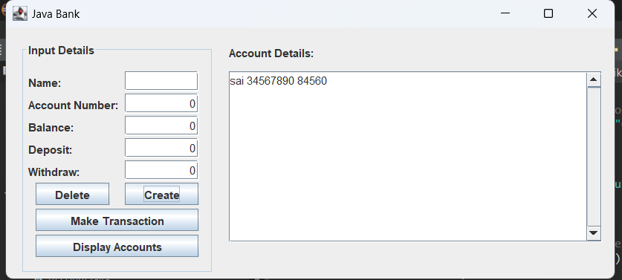

package bikeproject;

public class BikeDriver {

public static void main(String[] args) {

RoadBike bike1 = new RoadBike();

RoadBike bike2 = new RoadBike("drop", "tourer", "semi-grip", "comfort", 14, 25, 18);

MountainBike bike3 = new MountainBike();

Bike bike4 = new Bike();

bike1.printDescription();

bike2.printDescription();

bike3.printDescription();

bike4.printDescription();

}//end method main

}//end class BikeDriver

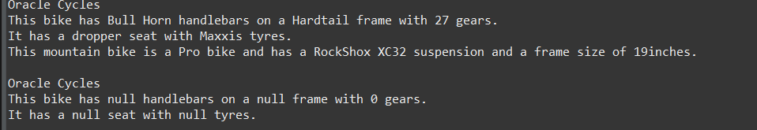

package bikeproject;

public class MountainBike extends Bike{

private String suspension, type;

private int frameSize;

public MountainBike()

{

this("Bull Horn", "Hardtail", "Maxxis", "dropper", 27, "RockShox XC32", "Pro", 19);

}//end constructor

public MountainBike(String handleBars, String frame, String tyres, String seatType, int numGears,

String suspension, String type, int frameSize) {

super(handleBars, frame, tyres, seatType, numGears);

this.suspension = suspension;

this.type = type;

this.frameSize = frameSize;

}//end constructor

public void printDescription()

{

super.printDescription();

System.***out***.println("This mountain bike is a " + this.type + " bike and has a " + this.suspension + " suspension and a frame size of " + this.frameSize + "inches.");

}//end method printDescription

}//end class MountainBike

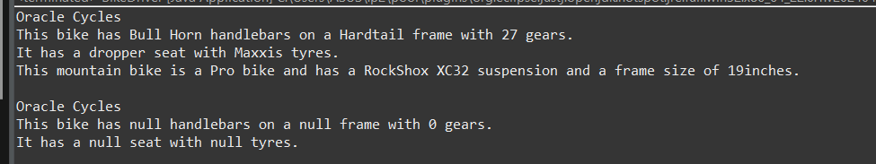

package bikeproject;

public class RoadBike extends Bike{

private int tyreWidth, postHeight;

public RoadBike()

{

this("drop", "racing", "tread less", "razor", 19, 20, 22);

}//end constructor

public RoadBike(int postHeight)

{

this("drop", "racing", "tread less", "razor", 19, 20, postHeight);

}//end constructor

public RoadBike(String handleBars, String frame, String tyres, String seatType, int numGears,

int tyreWidth, int postHeight) {

super(handleBars, frame, tyres, seatType, numGears);

this.tyreWidth = tyreWidth;

this.postHeight = postHeight;

}//end constructor

public void printDescription()

{

super.printDescription();

System.***out***.println("This Roadbike bike has " + this.tyreWidth + "mm tyres and a post height of " + this.postHeight + ".");

}//end method printDescription

}//end class RoadBike

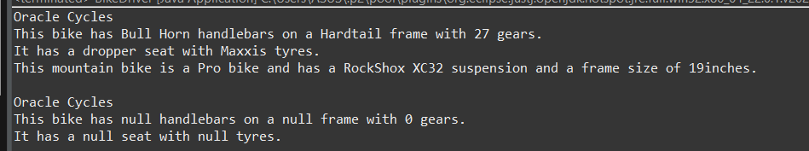

package bikeproject;

public class Bike {

private String handleBars, frame, tyres, seatType;

private int NumGears;

private final String make;

public Bike(){

this.make = "Oracle Cycles";

}//end constructor

public Bike(String handleBars, String frame, String tyres, String seatType, int numGears) {

this.handleBars = handleBars;

this.frame = frame;

this.tyres = tyres;

this.seatType = seatType;

NumGears = numGears;

this.make = "Oracle Cycles";

}//end constructor

protected void printDescription()

{

System.***out***.println("\n" + this.make + "\n"

+ "This bike has " + this.handleBars + " handlebars on a "

+ this.frame + " frame with " + this.NumGears + " gears."

+ "\nIt has a " + this.seatType + " seat with " + this.tyres + " tyres.");

}//end method printDescription

}//end class Bike

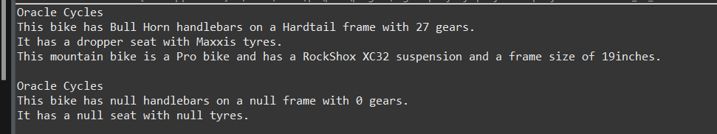

package helloworld;

import javax.swing.*;

import java.awt.Color;

import java.awt.event.ActionEvent;

import java.awt.event.ActionListener;

public class CalcPanel extends JPanel implements ActionListener {

String num1 = "";

String num2 = "";

String operator = "";

boolean usingFirst = true;

double total = 0;

JTextField display;

JButton b1, b2, b3, b4, b5, b6, b7, b8, b9, b0, bdec, bclear, bequals, bplus;

public CalcPanel() {

this.setBackground(Color.white);

setLayout(null);

display = new JTextField();

b1 = new JButton("1");

b2 = new JButton("2");

b3 = new JButton("3");

b4 = new JButton("4");

b5 = new JButton("5");

b6 = new JButton("6");

b7 = new JButton("7");

b8 = new JButton("8");

b9 = new JButton("9");

b0 = new JButton("0");

bdec = new JButton(".");

bclear = new JButton("C");

bequals = new JButton("=");

bplus = new JButton("+");

display.setBounds(0, 0, 205, 50);

b1.setBounds(0, 200, 50, 50);

b2.setBounds(50, 200, 50, 50);

b3.setBounds(100, 200, 50, 50);

bplus.setBounds(154, 200, 50, 50);

b4.setBounds(0, 150, 50, 50);

b5.setBounds(50, 150, 50, 50);

b6.setBounds(100, 150, 50, 50);

b7.setBounds(0, 100, 50, 50);

b8.setBounds(50, 100, 50, 50);

b9.setBounds(100, 100, 50, 50);

b0.setBounds(0, 250, 50, 50);

bdec.setBounds(50, 250, 50, 50);

bclear.setBounds(100, 250, 50, 50);

bequals.setBounds(154, 250, 50, 50);

add(b1);

add(b2);

add(b3);

add(b4);

add(b5);

add(b6);

add(b7);

add(b8);

add(b9);

add(b0);

add(bdec);

add(display);

add(bclear);

add(bequals);

add(bplus);

b1.addActionListener(this);

b2.addActionListener(this);

b3.addActionListener(this);

b4.addActionListener(this);

b5.addActionListener(this);

b6.addActionListener(this);

b7.addActionListener(this);

b8.addActionListener(this);

b9.addActionListener(this);

b0.addActionListener(this);

bequals.addActionListener(this);

bplus.addActionListener(this);

bclear.addActionListener(this);

bdec.addActionListener(this);

}

public void actionPerformed(ActionEvent e) {

String s = e.getActionCommand();

if (s.equals("1") || s.equals("2") || s.equals("3") || s.equals("4") ||

s.equals("5") || s.equals("6") || s.equals("7") || s.equals("8") ||

s.equals("9") || s.equals("0") || s.equals(".")) {

if (usingFirst) {

num1 = num1 + s;

display.setText(num1);

} else {

num2 = num2 + s;

display.setText(num2);

}

}

if (s.equals("+")) {

usingFirst = false;

operator = "+";

}

if (s.equals("=")) {

switch (operator) {

case "+":

total = Double.*parseDouble*(num1) + Double.*parseDouble*(num2);

display.setText("" + total);

break;

}

usingFirst = true;

num1 = "";

num2 = "";

operator = "";

}

if (s.equals("C")) {

display.setText("");

usingFirst = true;

num1 = "";

num2 = "";

total = 0;

}

}

// Main method to run the CalcPanel class

public static void main(String[] args) {

JFrame frame = new JFrame("Calculator");

frame.setDefaultCloseOperation(JFrame.EXIT_ON_CLOSE);

frame.setSize(220, 350); // Adjust size as needed

frame.add(new CalcPanel());

frame.setVisible(true);

}

}

